MASCHERPA Audric ROB 3 2022 / 2023

**POLY-SNAKE**

**Weekly report n°11 from 01/02/23 :**

Following the previous session and the arrival of the open day at the Polytech Sophia Nice engineering school, the focus during this session was on finishing the 3D modeling of the body of the Polysnake as well as the finalization of the program allowing him to move.

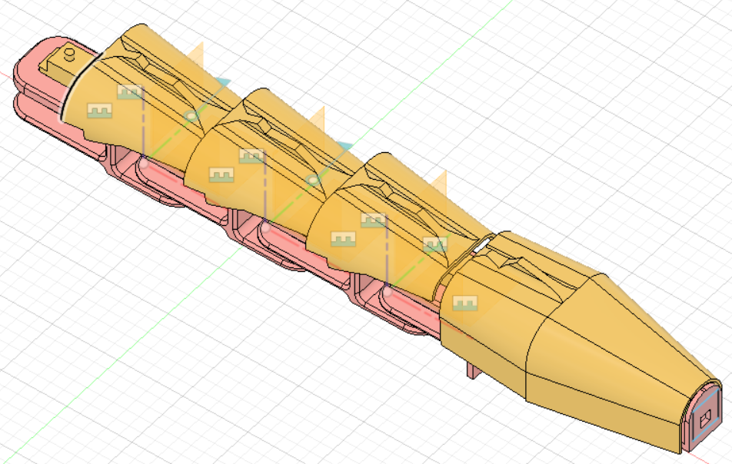The objective was to fine-tune the details so that everything was ready for the open day. Thus, the modeling of the snake's body has been slightly modified such as the aesthetic appearance of the skull or even some slight details on the rigidity of the parts in figure 11.1.

Figure 11.1

Then, my binome and I finalized the snake program as well as its readability.

Here a link to the program : <https://github.com/YOUSSNDR/PolySnake/tree/main/programmes>

Finally, it was decided to use skid pads to be placed under the polysnake modules in order to reduce friction on the ground and to limit the power of the motor present in the crane of the project in figure 11.2.

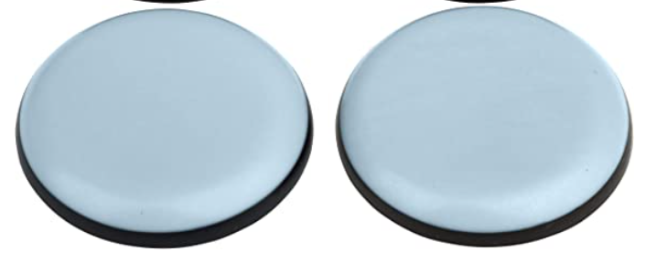

Figure 11.2